Student worksheet

1.1 Science is the study of the natural and physical world

Pages 2–3 and 170

What is science?

1 Which type of scientist would be the best or most appropriate one to investigate the following situations?

a A species of coral living in the Great Barrier Reef is dying unexpectedly.

b A fossilised ancient kangaroo has been discovered in the Simpson Desert.

c An area of the Wilson’s Promontory National Park is drying out because of climate change.

d There is a possible tropical cyclone threat to northern Queensland.

e A drug to treat a new strain of the Avian Bird Flu is needed.

2 Describe what this scientist might be doing.

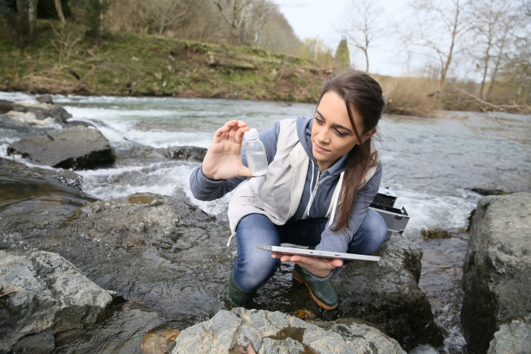

3 Write your own example of a situation where the following scientists would be required:

a Pharmacologist

b Palaeontologist

c Environmental scientist

d Meteorologist

e Marine biologist

f Nanotechnologist

EXTEND YOUR UNDERSTANDING

4 Find out what these scientists study: zoologist, geneticist, seismologist, astronomer. You could use the Internet or you may have a relative or someone you know who is in these fields of science.

Student worksheet

1.2 Scientists use specialised equipment

Pages 4–5 and 171

Lab Equipment

This worksheet could be completed as a quiz or you could use it to revise the various types of specialised equipment used in the science laboratory.

1 Below are a series of scientific diagrams of different types of common laboratory equipment. Write the name of the equipment and a short description of how the equipment is used.

|  |  |  |
| --- | --- | --- |
| a | WS0105_00883-r_v2 |  |
| b | WS0106_00883-r |  |
| c | WS0107_00883-r |  |
| d | WS0108_00883-r |  |
| e | WS0109_00883-r |  |
| f | WS0110_00883-r |  |
| g | WS0111_00883-r |  |
| h | WS0112_00883-r |  |
| i | WS0113_00883-r |  |
| j | WS0114_00883-r |  |
| k | WS0115_00883-r |  |
| l | WS0116_00883-r |  |
| m | WS0117_00883-r |  |
| n | WS0118_00883-r |  |
| o | WS0119_00883-r |  |
| p | WS0120_00883-r |  |
| q | WS0121_00883-r |  |

EXTEND YOUR UNDERSTANDING

2 Research the laboratory equipment that is required for distillation.

Student worksheet

1.3 Scientists take safety precautions

Pages 6–7

Safety in the lab

1 Read through the story below and identify as many ‘laboratory dos’ as you can. Write them in the space provided.

Two students, Rod Stirring and Connie Calflask, were preparing to conduct a simple experiment to observe the rate at which ice melts. They both listened carefully as their teacher explained the experimental procedure. Rod and Connie put on their lab coats and buttoned them up, and Connie tied her hair back. They then put their textbooks and workbooks under their desk. Rod gathered the Bunsen burner, tripod and gauze mat and placed them onto a bench mat. Connie gathered the beaker and a container of ice and placed these on the bench mat.

Rod and Connie set up the Bunsen burner equipment and placed the beaker with ice on top of the gauze mat. Before lighting the Bunsen burner, both Rod and Connie put their safety glasses on. Connie lit the Bunsen burner and they both recorded their observations.

When the ice had completely melted, they began cleaning up, but Rod accidentally knocked the beaker onto the floor and it broke. He told his teacher straight away. After the equipment had cooled down, they put it all away, washed their hands and put their lab coats and glasses away.

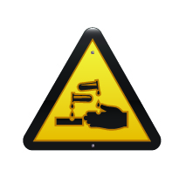

2 What do you think this symbol means?

3 Why is it relevant to a science laboratory?

4 Read through the story below and identify as many ‘laboratory don’ts’ as you can. Write them in the space provided.

Two students, Bea Kerr and Tess Tube, were preparing to conduct a simple experiment to observe the rate at which ice melts. They both listened to their iPods as their teacher explained the experimental procedure. Bea put a lab coat on, but didn’t button it up. Tess didn’t wear a lab coat because it didn’t match her shoes. Tess didn’t tie her hair back because she had had it straightened that morning. Both left their textbooks and workbooks on their bench. Bea gathered the Bunsen burner, tripod and gauze mat and placed them onto the bench. Tess gathered the beaker and a container of ice and placed these on the bench too.

Bea and Tess set up the Bunsen burner equipment and placed the beaker with ice on top of the gauze mat, but neither of them put their safety glasses on. Tess lit the Bunsen burner and they both walked away and had a chat with their friends.

When the ice had completely melted, they began cleaning up, but Bea and Tess were mucking around and knocked the beaker onto the floor and it broke. They kicked the broken glass under the bench. They picked up the equipment before it had cooled down, and both received minor burns on their hands. Both Bea and Tess left the classroom without putting all the equipment away.

EXTEND YOUR UNDERSTANDING

5 Research what these symbols mean.

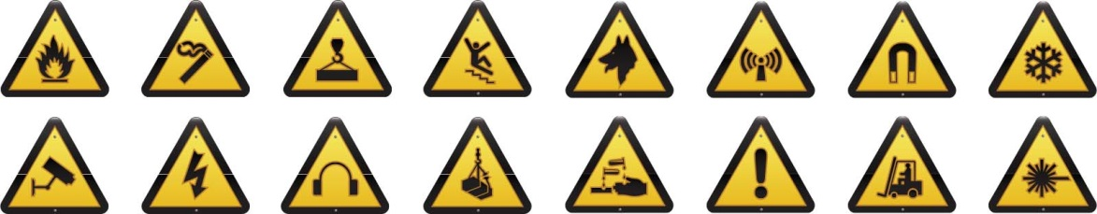

Student worksheet

1.4 Scientists use observation and inference to answer questions

Pages 8–9 and 172

Observation and inference

1 Beside each of the following observations, write whether they are a *qualitative* or *quantitative* observation.

a The liquid was very hot: \_\_\_\_\_\_\_\_\_\_\_\_\_\_\_\_\_\_\_\_\_\_\_\_\_\_\_\_\_\_\_\_\_\_\_\_\_\_\_\_\_\_\_\_\_\_\_\_\_\_\_\_\_\_\_\_\_\_

b The mouse was 4.5 centimetres long: \_\_\_\_\_\_\_\_\_\_\_\_\_\_\_\_\_\_\_\_\_\_\_\_\_\_\_\_\_\_\_\_\_\_\_\_\_\_\_\_\_\_\_\_\_\_\_

c The ball was travelling at 1 metre per second down the slope: \_\_\_\_\_\_\_\_\_\_\_\_\_\_\_\_\_\_\_\_\_\_\_\_\_\_\_\_

d I heard the chemicals fizzing: \_\_\_\_\_\_\_\_\_\_\_\_\_\_\_\_\_\_\_\_\_\_\_\_\_\_\_\_\_\_\_\_\_\_\_\_\_\_\_\_\_\_\_\_\_\_\_\_\_\_\_\_\_\_

e It took 6.7 seconds for the metal to dissolve: \_\_\_\_\_\_\_\_\_\_\_\_\_\_\_\_\_\_\_\_\_\_\_\_\_\_\_\_\_\_\_\_\_\_\_\_\_\_\_\_\_\_

f The chemical reaction caused a 76.3°C increase in temperature: \_\_\_\_\_\_\_\_\_\_\_\_\_\_\_\_\_\_\_\_\_\_\_\_\_\_

g I could smell the sulphur dioxide during the experiment: \_\_\_\_\_\_\_\_\_\_\_\_\_\_\_\_\_\_\_\_\_\_\_\_\_\_\_\_\_\_\_\_\_

h The surface of the bench felt rough: \_\_\_\_\_\_\_\_\_\_\_\_\_\_\_\_\_\_\_\_\_\_\_\_\_\_\_\_\_\_\_\_\_\_\_\_\_\_\_\_\_\_\_\_\_\_\_\_\_

i The substance turned blue when it was heated over the Bunsen burner: \_\_\_\_\_\_\_\_\_\_\_\_\_\_\_\_\_\_\_\_

j The 50 millilitres of water evaporated from the beaker: \_\_\_\_\_\_\_\_\_\_\_\_\_\_\_\_\_\_\_\_\_\_\_\_\_\_\_\_\_\_\_\_\_\_

2 What are three reasons why you should not smell things in a test tube unless your teacher instructs you to?

3 Here is a picture of Dr Redback and his family (you may meet them again during your study of Chapter 5). Determine whether the following statements are observations or inferences

**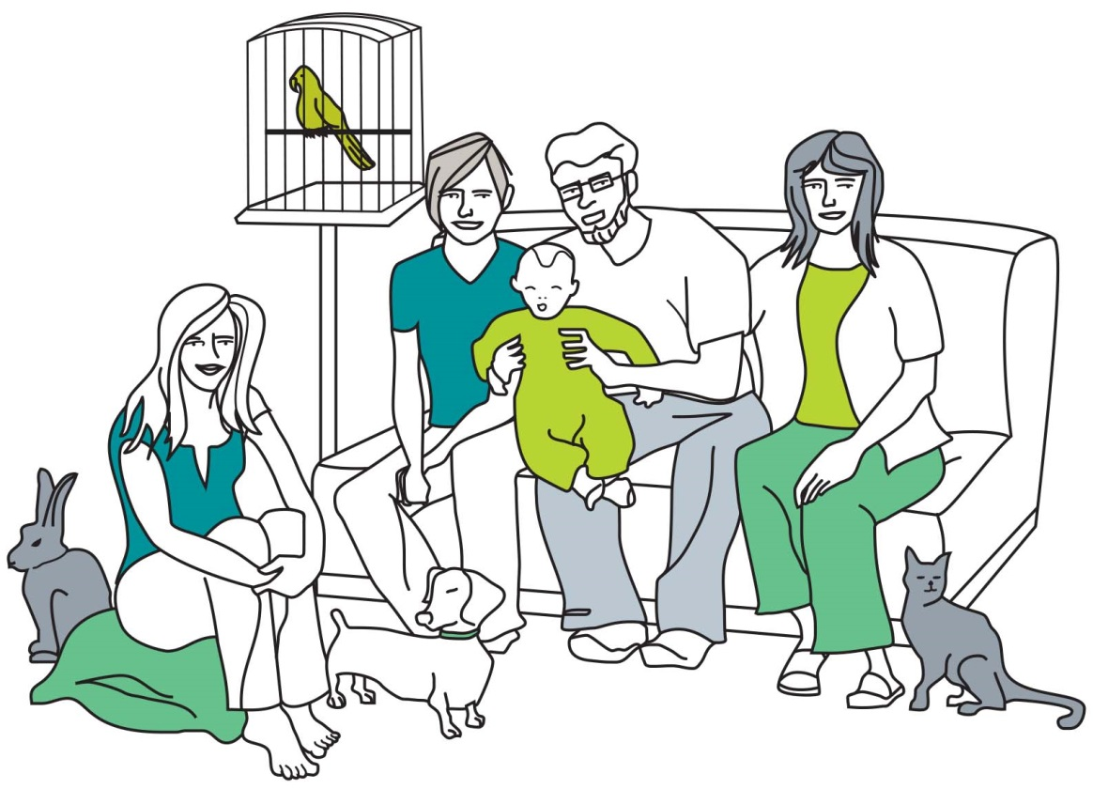**

a One person is sitting on a pillow on the floor: \_\_\_\_\_\_\_\_\_\_\_\_\_\_\_\_\_\_\_\_\_\_\_\_\_\_\_\_\_\_\_\_\_\_\_\_\_\_\_\_\_\_

b There is a bird in the birdcage: \_\_\_\_\_\_\_\_\_\_\_\_\_\_\_\_\_\_\_\_\_\_\_\_\_\_\_\_\_\_\_\_\_\_\_\_\_\_\_\_\_\_\_\_\_\_\_\_\_\_\_\_\_

c The cat’s name is Mr Fluffy: \_\_\_\_\_\_\_\_\_\_\_\_\_\_\_\_\_\_\_\_\_\_\_\_\_\_\_\_\_\_\_\_\_\_\_\_\_\_\_\_\_\_\_\_\_\_\_\_\_\_\_\_\_\_\_

d The family are watching television: \_\_\_\_\_\_\_\_\_\_\_\_\_\_\_\_\_\_\_\_\_\_\_\_\_\_\_\_\_\_\_\_\_\_\_\_\_\_\_\_\_\_\_\_\_\_\_\_\_\_

e There are five people in the picture: \_\_\_\_\_\_\_\_\_\_\_\_\_\_\_\_\_\_\_\_\_\_\_\_\_\_\_\_\_\_\_\_\_\_\_\_\_\_\_\_\_\_\_\_\_\_\_\_\_

f Dr Redback is probably holding his grandson: \_\_\_\_\_\_\_\_\_\_\_\_\_\_\_\_\_\_\_\_\_\_\_\_\_\_\_\_\_\_\_\_\_\_\_\_\_\_\_\_\_

EXTEND YOUR UNDERSTANDING

4 Find out how inferences and observations have helped scientists determine what Tyrannosaurus rex’s appearance and behaviour were like.

Student worksheet

1.5 Science relies on measuring with accuracy

Pages 10–13 and 172

Measuring in the lab

1 Rearrange the letters of each word to work out the measurement:

a sams: \_\_\_\_\_\_\_\_\_\_\_\_\_\_\_\_\_\_\_\_\_\_\_\_\_\_\_\_\_\_\_\_\_\_\_\_\_\_\_\_\_\_\_\_\_\_\_\_\_\_\_\_\_\_\_\_\_\_\_\_\_\_\_\_

b tereprmueat: \_\_\_\_\_\_\_\_\_\_\_\_\_\_\_\_\_\_\_\_\_\_\_\_\_\_\_\_\_\_\_\_\_\_\_\_\_\_\_\_\_\_\_\_\_\_\_\_\_\_\_\_\_\_\_\_\_\_\_\_\_\_\_\_

c thenlg: \_\_\_\_\_\_\_\_\_\_\_\_\_\_\_\_\_\_\_\_\_\_\_\_\_\_\_\_\_\_\_\_\_\_\_\_\_\_\_\_\_\_\_\_\_\_\_\_\_\_\_\_\_\_\_\_\_\_\_\_\_\_\_\_

d uvelmo: \_\_\_\_\_\_\_\_\_\_\_\_\_\_\_\_\_\_\_\_\_\_\_\_\_\_\_\_\_\_\_\_\_\_\_\_\_\_\_\_\_\_\_\_\_\_\_\_\_\_\_\_\_\_\_\_\_\_\_\_\_\_\_\_

e emit: \_\_\_\_\_\_\_\_\_\_\_\_\_\_\_\_\_\_\_\_\_\_\_\_\_\_\_\_\_\_\_\_\_\_\_\_\_\_\_\_\_\_\_\_\_\_\_\_\_\_\_\_\_\_\_\_\_\_\_\_\_\_\_\_

2 Work out these clues to determine the unit of measurement:

a I wanted to meet her but I waited too long: \_\_\_\_\_\_\_\_\_\_\_\_\_\_\_\_\_\_\_\_\_\_\_\_\_\_\_\_\_\_\_\_\_\_\_\_\_\_\_\_\_\_\_\_

b Not backwards, any end: \_\_\_\_\_\_\_\_\_\_\_\_\_\_\_\_\_\_\_\_\_\_\_\_\_\_\_\_\_\_\_\_\_\_\_\_\_\_\_\_\_\_\_\_\_\_\_\_\_\_\_\_\_\_\_\_\_

c I came first, she came third, you came where? \_\_\_\_\_\_\_\_\_\_\_\_\_\_\_\_\_\_\_\_\_\_\_\_\_\_\_\_\_\_\_\_\_\_\_\_\_\_\_\_

d For one cent I met really famous scientists: \_\_\_\_\_\_\_\_\_\_\_\_\_\_\_\_\_\_\_\_\_\_\_\_\_\_\_\_\_\_\_\_\_\_\_\_\_\_\_\_\_\_\_

e Oh you are late. \_\_\_\_\_\_\_\_\_\_\_\_\_\_\_\_\_\_\_\_\_\_\_\_\_\_\_\_\_\_\_\_\_\_\_\_\_\_\_\_\_\_\_\_\_\_\_\_\_\_\_\_\_\_\_\_\_\_\_\_\_\_\_\_

f Your gramma’s grammar is unbalanced. \_\_\_\_\_\_\_\_\_\_\_\_\_\_\_\_\_\_\_\_\_\_\_\_\_\_\_\_\_\_\_\_\_\_\_\_\_\_\_\_\_\_\_\_\_

g The tiler relit the flame. \_\_\_\_\_\_\_\_\_\_\_\_\_\_\_\_\_\_\_\_\_\_\_\_\_\_\_\_\_\_\_\_\_\_\_\_\_\_\_\_\_\_\_\_\_\_\_\_\_\_\_\_\_\_\_\_\_\_\_

h This unit is cagey. \_\_\_\_\_\_\_\_\_\_\_\_\_\_\_\_\_\_\_\_\_\_\_\_\_\_\_\_\_\_\_\_\_\_\_\_\_\_\_\_\_\_\_\_\_\_\_\_\_\_\_\_\_\_\_\_\_\_\_\_\_\_\_

i The clues is ‘degrease’. \_\_\_\_\_\_\_\_\_\_\_\_\_\_\_\_\_\_\_\_\_\_\_\_\_\_\_\_\_\_\_\_\_\_\_\_\_\_\_\_\_\_\_\_\_\_\_\_\_\_\_\_\_\_\_\_\_\_

j I have never won, but came second 60 times by a tiny margin. \_\_\_\_\_\_\_\_\_\_\_\_\_\_\_\_\_\_\_\_\_\_\_\_\_\_\_\_

EXTEND YOUR UNDERSTANDING

3 Use the Internet to discover who the unit Celsius is named after. In addition, find out what the other two temperature scales used today are.

Student worksheet

1.6 A Bunsen burner is an essential piece of equipment

Pages 14–15

Bunsen burners

1 Fill in the labels surrounding the two Bunsen burner diagrams below from the list below.

• Air hole open

• Air hole closed

• Heating flame

• Safety flame

Draw and colour in the flames in either blue or yellow.

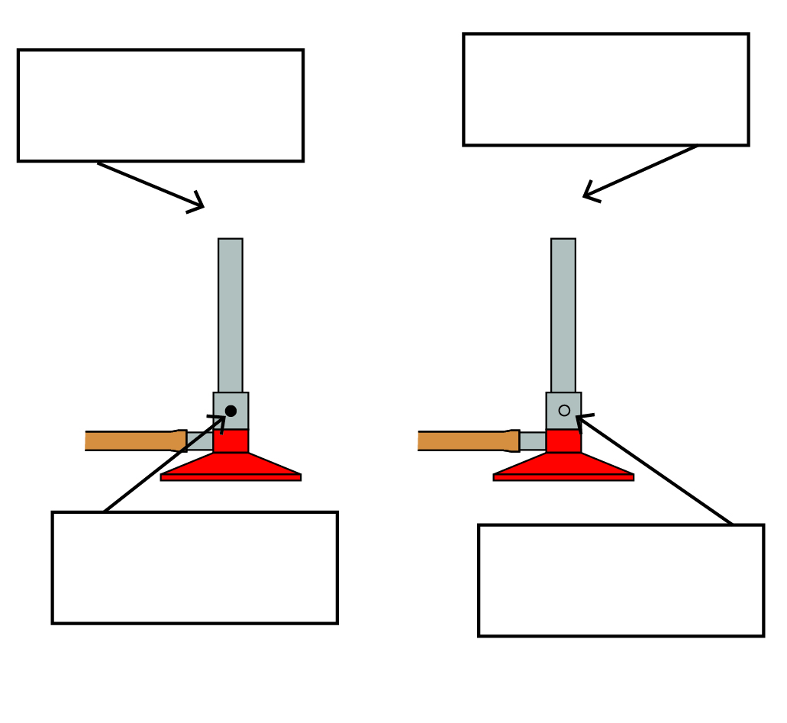

2 The descriptions below are the steps you should follow to light a Bunsen burner. Write the numbers 1 to 6 next to the appropriate description to indicate the order of the steps.

• Open the gas tap fully. \_\_\_\_\_\_\_

• Light a match and place it above the barrel, with your hand below the flame. \_\_\_\_\_\_\_

• Connect the rubber hosing firmly to the gas tap. \_\_\_\_\_\_\_

• Place the Bunsen burner on a heating mat. \_\_\_\_\_\_\_

• After you have followed these steps, the Bunsen burner will have a yellow flame. \_\_\_\_\_\_\_

• Close the air hole by turning the collar. \_\_\_\_\_\_\_

3 a LPG is naturally odourless (you cannot smell it). Why do you think the gas supply companies add substances like hydrogen sulphide (rotten egg gas) to the LPG?

b What are two potential risks if the gas company did not add a smell to LPG?

EXTEND YOUR UNDERSTANDING

4 Find out about the inventor of the Bunsen burner. Who was the inventor? When was the burner invented? What other discoveries or inventions did this person make?

Student worksheet

1.7 A fair test is a controlled experiment

Pages 16–17

Controls

1 The following scenario describes a scientific investigation. Read the information and answer the questions.

Sue Doh liked to train for netball during the summer and wanted to know what coloured shirt would keep her the coolest. She decided to conduct a series of experiments to find out the answer. Sue assumed that white coloured clothes would be best because her mum’s white car was cooler inside compared with her dad’s dark coloured car. She found five different coloured squares of cotton cloth (white, purple, red, black, yellow and green). During the next really hot, sunny day she put squares of cloth on the trampoline in the backyard and put a thermometer underneath each cloth. She recorded the initial temperature of the five thermometers and the temperature on a thermometer lying on the trampoline but not under any cloth. She waited 5 minutes and wrote down the temperatures on all the thermometers. Sue decided to repeat her experiment three more times and recorded this information in a table of results for further analysis.

a What was Sue’s hypothesis?

b What was the independent variable in Sue’s experiment?

c What was the dependent variable in Sue’s experiment?

d What variables were controlled in Sue’s investigation?

e How did Sue attempt to improve the reliability of her investigation?

f Was Sue’s experiment a fair test? Why or why not?

g How could Sue’s experiment be improved so her results are more reliable?

2 The following scenario describes a scientific investigation that a student, Con Trollé, conducted at home. Read the information and answer the questions.

Con wants to discover whether eating chocolate biscuits after school will affect the amount of food someone eats at dinnertime. To find out, Con chose four people to be test subjects. For 3 days, he will give them three chocolate biscuits after school. He will serve the same food for dinner for those 3 days and the test subjects will eat dinner at the same time every day. After 3 days of eating biscuits after school, he will then have the people have dinner for 3 days without eating biscuits after school. The test subjects will still have the same food for dinner and also eat at the same time. Con will measure and compare how much food they eat in the 3 days after eating biscuits and in the 3 days on which they didn’t have any biscuits.

a What is the independent variable in Con’s investigation?

b What is the dependent variable in Con’s investigation?

c What are the controls in Con’s investigation?

EXTEND YOUR UNDERSTANDING

3 Phrenology is regarded as a branch of pseudoscience (meaning it has no real scientific foundation and isn’t based on evidence).

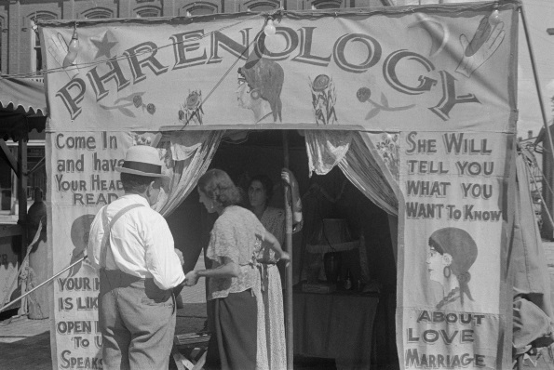

Find out:

a what Phrenology was

b when it originated

c what practitioners of Phrenology did

d whether there was any scientific merit to this pseudoscience.

Student worksheet

1.8 Graphs and tables are used to show results

Pages18–21 and 173

Displaying results

1 Use the data in the results table to complete an appropriate graph in the space provided.

Change in water temperature over time

|  |  |
| --- | --- |
| Time (minutes) | Temperature (°C) |
| 5 | 43 |
| 10 | 37 |
| 15 | 35 |
| 20 | 24 |

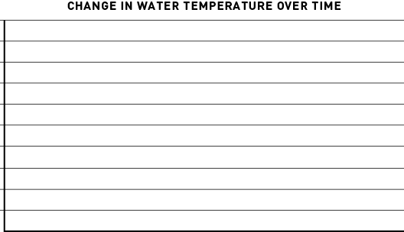

a What is the dependent variable?

b What is the independent variable?

2 Examine the graph below and answer the following questions.

a What type of graph is this?

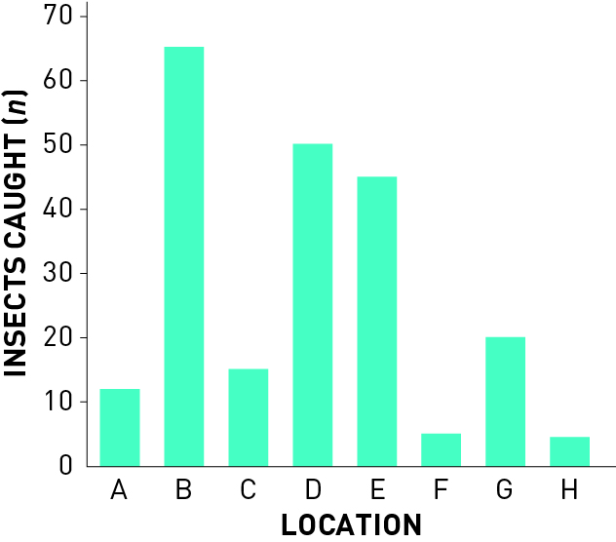

b Write an appropriate title for this graph.

c What is the dependent variable?

d What is the independent variable?

e Which location had the highest number of insects caught? \_\_\_\_\_\_\_\_\_\_\_\_\_\_\_\_\_\_\_\_­\_\_\_\_\_\_\_\_\_\_\_

f Which location had the lowest number of insects caught? \_\_\_\_\_\_\_\_­­­­­­­­­­­­\_\_\_\_\_\_\_\_\_\_\_\_\_\_\_\_\_\_\_\_\_\_\_\_

g How many insects were caught at location:

i C? \_\_\_\_\_\_\_\_\_\_\_

ii D? \_\_\_\_\_\_\_\_\_\_\_

iii G? \_\_\_\_\_\_\_\_\_\_\_

EXTEND YOUR UNDERSTANDING

3 Use the Internet to find out:

a What is a pie chart?

b How could a pie chart be used to show the ‘insects caught’ data above?

Student worksheet

1.9 Scientific reports communicate findings

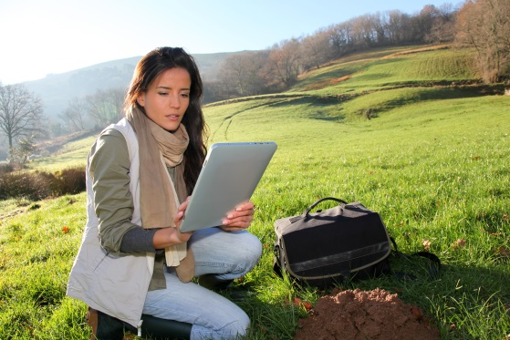Pages 22–23

Reporting

1 Trying to remember the eight parts of a scientific report can be a challenge at first. A way to remember the eight parts, and the order they come in, is to create a mnemonic (using the first letter of each word to create new words to form a sentence). For example, *Tiny Ants Healed Moths Meanwhile Rats Drew Cats*: ‘tiny’ for ‘title’, ‘ants’ for ‘aim’, and so on.

Write your own mnemonic next to the eights parts of a scientific report listed below:

a Title: \_\_\_\_\_\_\_\_\_\_\_\_\_\_\_\_\_\_\_\_\_\_\_\_\_\_\_\_\_\_\_\_\_\_\_\_\_\_\_\_\_\_\_\_\_\_\_\_\_\_\_\_\_\_\_\_

b Aim: \_\_\_\_\_\_\_\_\_\_\_\_\_\_\_\_\_\_\_\_\_\_\_\_\_\_\_\_\_\_\_\_\_\_\_\_\_\_\_\_\_\_\_\_\_\_\_\_\_\_\_\_\_\_\_\_

c Hypothesis: \_\_\_\_\_\_\_\_\_\_\_\_\_\_\_\_\_\_\_\_\_\_\_\_\_\_\_\_\_\_\_\_\_\_\_\_\_\_\_\_\_\_\_\_\_\_\_\_\_\_\_\_\_\_\_\_

d Materials: \_\_\_\_\_\_\_\_\_\_\_\_\_\_\_\_\_\_\_\_\_\_\_\_\_\_\_\_\_\_\_\_\_\_\_\_\_\_\_\_\_\_\_\_\_\_\_\_\_\_\_\_\_\_\_\_

e Method: \_\_\_\_\_\_\_\_\_\_\_\_\_\_\_\_\_\_\_\_\_\_\_\_\_\_\_\_\_\_\_\_\_\_\_\_\_\_\_\_\_\_\_\_\_\_\_\_\_\_\_\_\_\_\_\_

f Results: \_\_\_\_\_\_\_\_\_\_\_\_\_\_\_\_\_\_\_\_\_\_\_\_\_\_\_\_\_\_\_\_\_\_\_\_\_\_\_\_\_\_\_\_\_\_\_\_\_\_\_\_\_\_\_\_

g Discussion: \_\_\_\_\_\_\_\_\_\_\_\_\_\_\_\_\_\_\_\_\_\_\_\_\_\_\_\_\_\_\_\_\_\_\_\_\_\_\_\_\_\_\_\_\_\_\_\_\_\_\_\_\_\_\_\_

h Conclusion: \_\_\_\_\_\_\_\_\_\_\_\_\_\_\_\_\_\_\_\_\_\_\_\_\_\_\_\_\_\_\_\_\_\_\_\_\_\_\_\_\_\_\_\_\_\_\_\_\_\_\_\_\_\_\_\_

2 What are two reasons to write a method?

3 How are results usually displayed?

EXTEND YOUR UNDERSTANDING

4 Research what a real bungee cord is made out of and how the operators adjust the cord depending on the weight of the jumper.

Student worksheet

1.10 Science as a human endeavour: Science skills are used to solve important problems

Pages 24–25

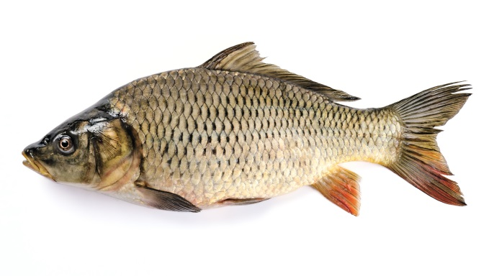Human endeavour

Cane toads are not the only introduced species that has caused major environmental issues in Australia; there are many other plant and animal species that are causing problems. Most of the waterways of the Murray–Darling Basin (a river basin that extends through Queensland, New South Wales, Victoria, the Australian Capital Territory and South Australia) have been infested by a fish called the European carp.

Carp were introduced into Australia in two ways. First they were introduced deliberately to make British settlers feel more like they were at home. Later, they were introduced accidentally when a number of ornamental carp in a private pond escaped into the wild. Carp are very good at adapting to different environments, so they are now found in many waterways around Australia. Carp can have many harmful effects on native animals and plants, mainly because of their destructive feeding habits. Carp are often found in environments that have been degraded (damaged). Scientists are not sure whether carp always cause this damage or if they are just better than native species at surviving in these degraded environments. Although it is clear that carp can have bring about very harmful effects on the Australian environment, in some cases carp have probably been blamed for degradation that is actually the result of human activities.

1 Design a simple experiment that scientists could conduct now that could investigate methods to control the carp population in the waterways of the Murray–Darling Basin.

a What is the aim of your experiment?

b What are three questions you could ask yourself before starting the experiment?

c Write a hypothesis based on one of your three questions.

d What experiment could you conduct to investigate your aim?

e Write some of the equipment you may need to conduct the experiment.

f How would you record your results?

g How would you present your results?

h What type of information would you include in your conclusion?

EXTEND YOUR UNDERSTANDING

2 Conduct further research about the impact of the European carp to help you with your responses to the questions in this worksheet. The following weblink is a useful place to start your research: <http://www.dpi.nsw.gov.au/fisheries/pests-diseases/freshwater-pests/species/carp/general-information>